**Semi Supervised Learning**

Semi-supervised machine learning is a type of machine learning that falls between supervised and unsupervised learning. In semi-supervised learning, the algorithm is trained on a combination of a small amount of labeled data and a larger amount of unlabeled data. This approach leverages the labeled data to guide the learning process and make better use of the unlabeled data.

### Key Points of Semi-Supervised Learning:

1. **Labeled and Unlabeled Data**: The dataset consists of a few labeled examples and many unlabeled examples. The labeled data helps in providing the initial learning, while the unlabeled data helps in improving the generalization ability of the model.
2. **Learning Process**: The model typically starts by learning from the labeled data. It then uses this initial model to predict labels for the unlabeled data, and iteratively refines its predictions. The process can be enhanced by using techniques like pseudo-labeling or self-training, where the model assigns labels to the unlabeled data based on its predictions and then re-trains itself.
3. **Advantages**:
   * **Cost-Effective**: Labeling large datasets can be expensive and time-consuming. Semi-supervised learning reduces the need for extensive labeled data.
   * **Improved Performance**: By leveraging both labeled and unlabeled data, semi-supervised learning can achieve better performance than purely supervised learning, especially when labeled data is scarce.
4. **Applications**: It is particularly useful in scenarios where obtaining labeled data is difficult, expensive, or time-consuming, such as in natural language processing, image recognition, and medical diagnosis.

### Examples of Semi-Supervised Learning Techniques:

1. **Self-Training**: The model is trained on labeled data, and then it uses its own predictions on unlabeled data as additional labeled examples for further training.
2. **Co-Training**: Two or more classifiers are trained on different views of the data (e.g., different feature sets), and they iteratively label the unlabeled data for each other.
3. **Graph-Based Methods**: These methods use graphs to represent the data, where nodes represent data points and edges represent similarities. Label propagation is a common technique where labels are spread through the graph based on the edges.
4. **Transductive Learning**: Unlike inductive learning which aims to create a general model, transductive learning focuses on predicting the labels of the given unlabeled data points.

### Practical Example:

Let's consider a scenario where you have a small labeled dataset of images of cats and dogs, and a large unlabeled dataset of images. A semi-supervised learning algorithm would:

1. Train an initial model using the labeled images.
2. Use the model to predict labels for the unlabeled images.
3. Refine the model using both the labeled images and the newly labeled (predicted) images.
4. Repeat the process until the model's performance stabilizes.

In summary, semi-supervised learning is a powerful approach that combines the strengths of supervised and unsupervised learning to make efficient use of both labeled and unlabeled data, enhancing the learning process and improving model performance.

**Reinforcement Learning**

Reinforcement Learning (RL) is a type of machine learning where an agent learns to make decisions by performing certain actions and receiving feedback from those actions in the form of rewards or penalties. The goal is for the agent to learn a strategy, or policy, that maximizes the cumulative reward over time.

### Key Components of Reinforcement Learning:

1. **Agent**: The learner or decision-maker.
2. **Environment**: The external system with which the agent interacts.
3. **State**: A representation of the current situation of the agent within the environment.
4. **Action**: Choices that the agent can make.
5. **Reward**: Feedback from the environment based on the action taken. It can be positive (reward) or negative (penalty).
6. **Policy**: A strategy that the agent employs to determine the next action based on the current state.
7. **Value Function**: A function that estimates the expected cumulative reward of a state or state-action pair.

### How Reinforcement Learning Works:

1. **Initialization**: The agent starts with no knowledge of the environment and initializes its policy randomly.
2. **Interaction**: The agent interacts with the environment by taking actions based on its current policy.
3. **Feedback**: The environment responds to the action by providing a new state and a reward.
4. **Update**: The agent updates its policy and value functions based on the feedback to improve its future actions.
5. **Iteration**: This process repeats, with the agent continually improving its policy to maximize cumulative rewards.

### Types of Reinforcement Learning:

* **Model-Free RL**: The agent learns the policy without explicitly modeling the environment. Common approaches include:
  + **Q-Learning**: The agent learns the value of state-action pairs.
  + **Policy Gradient Methods**: The agent directly learns the policy that maps states to actions.
* **Model-Based RL**: The agent builds a model of the environment and uses it to plan actions by simulating potential future states.

### Applications of Reinforcement Learning:

* **Game Playing**: RL has been successfully used in games like chess, Go, and video games.
* **Robotics**: RL helps robots learn tasks such as walking, grasping, and navigating.
* **Recommendation Systems**: RL can optimize recommendations by learning user preferences over time.
* **Finance**: RL can be used for portfolio management and trading strategies.

### Example of Reinforcement Learning:

Consider a robot in a maze. The robot (agent) must learn to navigate the maze (environment) to reach the goal. Each movement (action) changes the robot's position (state), and it receives rewards for reaching the goal or penalties for hitting walls. The robot updates its navigation strategy (policy) based on the feedback to find the optimal path.

In summary, reinforcement learning is a powerful technique where an agent learns to make decisions through trial and error, receiving feedback from the environment to improve its actions and achieve long-term goals.

**Metric of linear regression**

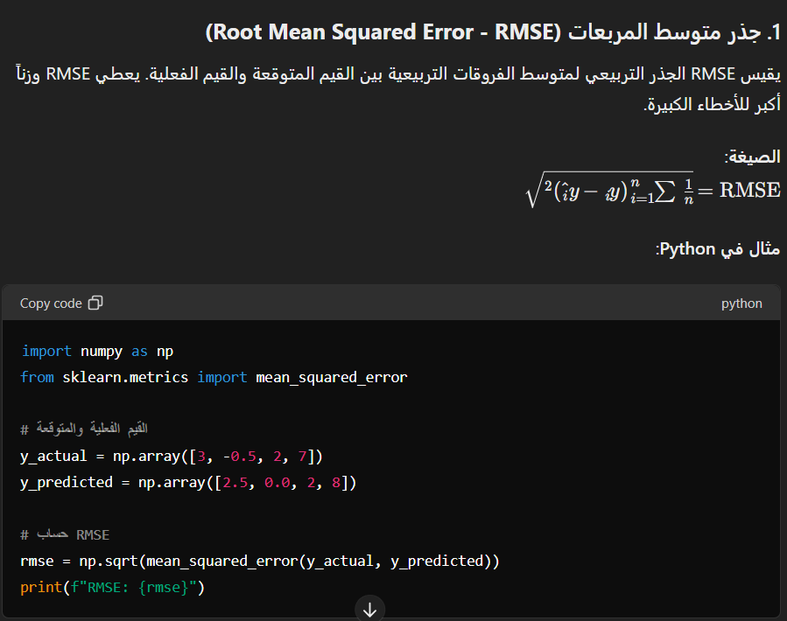

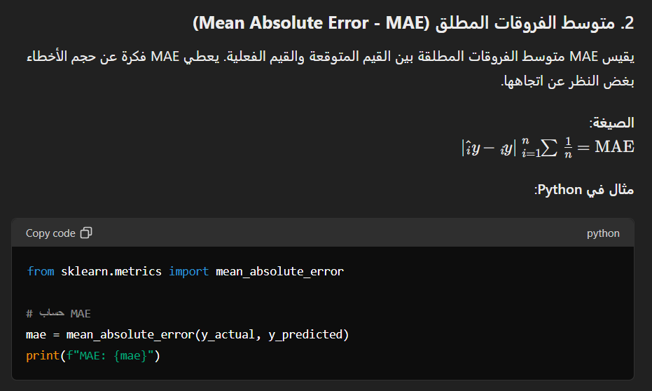

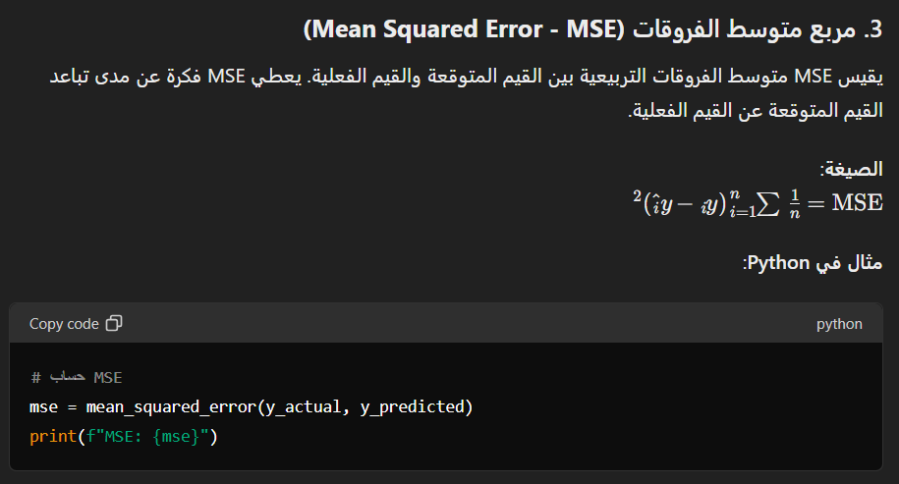

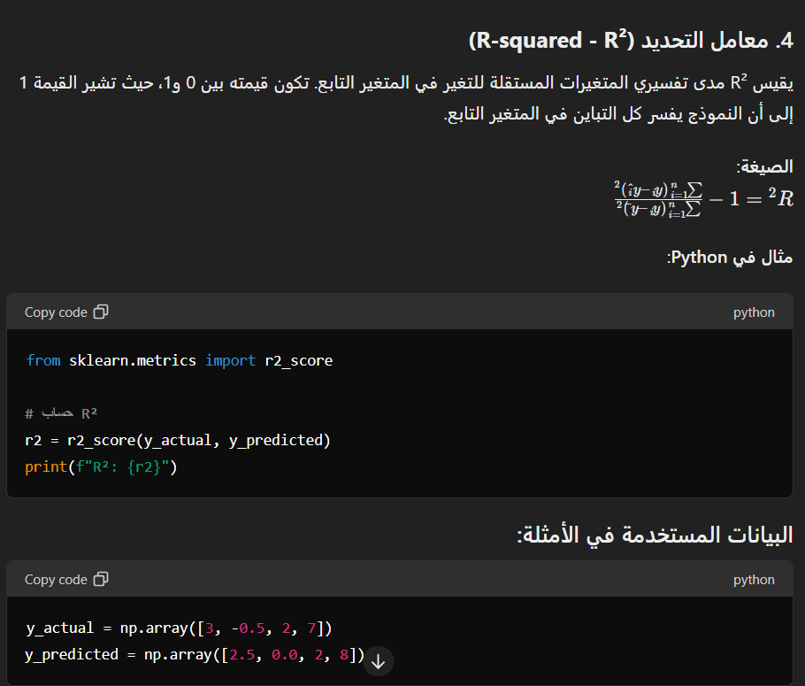

**Label Encoder**

A **Label Encoder** is a tool used in machine learning to convert categorical data into numerical data that models can work with. Often, categorical data consists of text labels (such as category names), which need to be transformed into numbers before a model can use them.

### How Label Encoder Works:

The label encoder assigns each unique category in the dataset a unique integer. For example, if we have a category with color names ["Red", "Blue", "Green"], it will be converted into numbers like [0, 1, 2].

### Steps to Use Label Encoder:

1. **Import the Library**: The Scikit-Learn library in Python is commonly used for this purpose.
2. **Initialize the Encoder**: Create an instance of the LabelEncoder class.
3. **Fit and Transform**: Pass the categorical data to the encoder to learn the unique categories and then transform them into numbers.

### When to Use Label Encoder:

* When you have categorical data that needs to be converted to numbers for use in machine learning models.
* When you want to use a model that requires numerical input only.

### Note:

In some cases, encoding categorical data can impact model performance, especially if the categories have a natural order (ordinal). In such cases, other techniques like One-Hot Encoding might be considered.

In summary, the Label Encoder is a simple and effective tool for converting categorical data into numbers, facilitating the use of this data in machine learning models.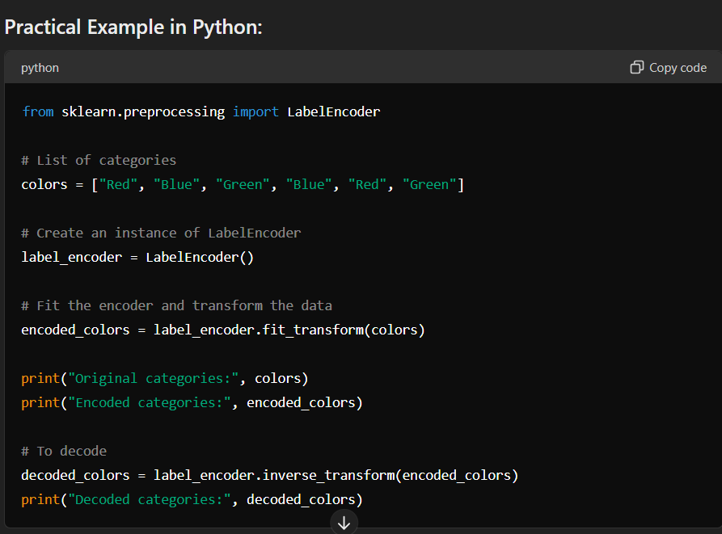

**One Hot Encoder**

One hot encoding is a technique used in machine learning and data processing to convert categorical variables into a format that can be provided to machine learning algorithms to improve predictions. Here's how it works and why it's used:

### How One Hot Encoding Works:

1. **Categorical Variables**: Categorical variables are variables that contain a finite number of categories or distinct groups. For example, "Gender" could be a categorical variable with categories "Male" and "Female".
2. **Problem with Categorical Variables**: Many machine learning algorithms cannot directly handle categorical data in their raw form. They require numerical input vectors.
3. **One Hot Encoding Process**:
   * Each category is converted into a new binary column (or feature).
   * If there are n unique categories, the one hot encoding process will create n new columns.
   * Each column corresponds to one unique category and contains binary values (0 or 1), where 1 denotes the presence of the category and 0 denotes the absence.
4. **Example**:
   * Suppose you have a categorical variable "Color" with three categories: Red, Blue, and Green.
   * After one hot encoding, you would create three new binary columns:
     + Red: [1, 0, 0]
     + Blue: [0, 1, 0]
     + Green: [0, 0, 1]

### Why Use One Hot Encoding?

1. **Compatibility with Algorithms**: Many machine learning algorithms (like linear regression, logistic regression, neural networks) require numerical input. One hot encoding transforms categorical data into a format that these algorithms can work with.
2. **Preventing Bias**: Encoding categorical variables with integer labels (e.g., 1 for Red, 2 for Blue) can introduce unintended relationships or ordinality (where no such relationship exists). One hot encoding avoids this issue by creating separate binary columns.
3. **Interpretability**: One hot encoding preserves the categorical nature of the variable in a more interpretable way. Each category is explicitly represented by its own binary feature.

### Implementation in Python:

In Python, you can use libraries like pandas or scikit-learn to perform one hot encoding:

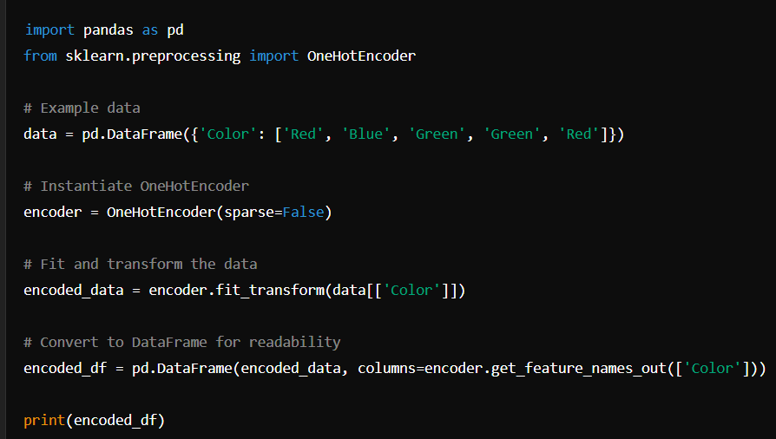

This example demonstrates how OneHotEncoder from scikit-learn can be used to transform a categorical variable ('Color') into a set of binary columns representing each category. Each row corresponds to an original data point, and each column corresponds to a category after one hot encoding.

In summary, one hot encoding is a fundamental preprocessing step in machine learning pipelines, especially when dealing with categorical data, enabling algorithms to effectively process and learn from such data.